**Capstone Project – Phase 4 Report**

1. **Objective**

In this phase we have to create a pluggable database (pdb) that will be a unique environment for the Inventory Management system.

1. **Database Naming**

Following the project rules, the pluggable database is : e_27406_shyaka_inventory_db

1. **Database Creation Process**

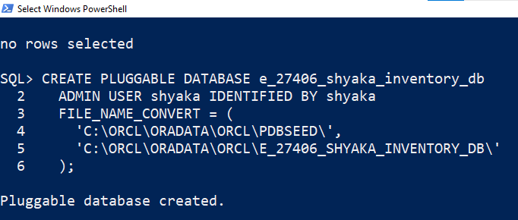

After creating the database, we opened it and saved it as follows;

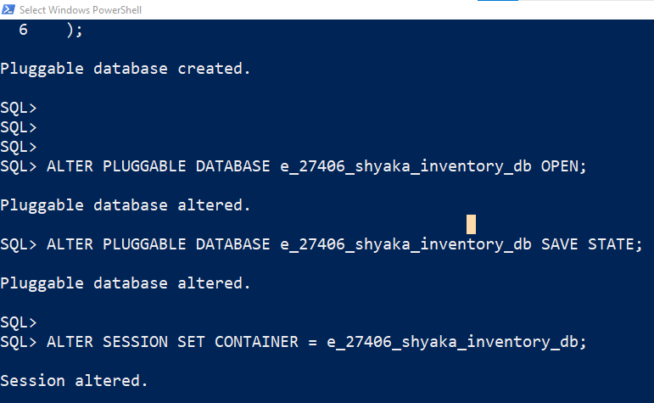

We used sql Plus tool to create it.

1. **OEM Monitoring**
2. **Screenshots Evidence:** some of the evidences have been shown Above.
3. **Conclusion:**

The pdb “e_27406_shyaka_inventory_db” was successfully created, configured and tested.